Chapter 5, Solution 48.

The circuit in Fig. 5.80 is a differential amplifier driven by a bridge. Find v_{o}.
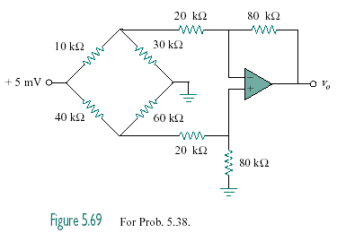

+15.5 mV

Figure 5.80
For Prob. 5.48.

Solution

We can break this problem up into parts. The 15.5 mV source separates the lower circuit from the upper. In addition, there is no current flowing into the input of the op amp which means we now have the 40-kohm resistor in series with a parallel combination of the 60-kohm resistor and the equivalent 100-kohm resistor.

Thus, 40k + (60x100k)/(160) = 77.5k

which leads to the current flowing through this part of the circuit,

i = 15.5 m/77.5k = 200x10^{–9} A

The voltage across the 60k and equivalent 100k is equal to,

v = ix37.5k = 7.5 mV

We can now calculate the voltage across the 80-kohm resistor.

v₈₀ = 0.8x7.5 m = 6 mV

which is also the voltage at both inputs of the op amp and the voltage between the 20-kohm and 80-kohm resistors in the upper circuit. Let v₁ be the voltage to the left of the 20-kohm resistor of the upper circuit and we can write a node equation at that node.

(v₁–15.5m)/(10k) + v₁/30k + (v₁–6m)/20k = 0

or 6v₁ – 93 + 2v₁ + 3v₁ – 18 = 0 or v₁ = 10.091 mV.

The current through the 20k-ohm resistor, left to right, is,

i₂₀ = (10.091m–6m)/20k = 204.55x10^{–9} A

thus, v_{o} = 6m – 204.55x10^{–9}x80k = –10.364 mV.

